New Loop Simulation and Outputs
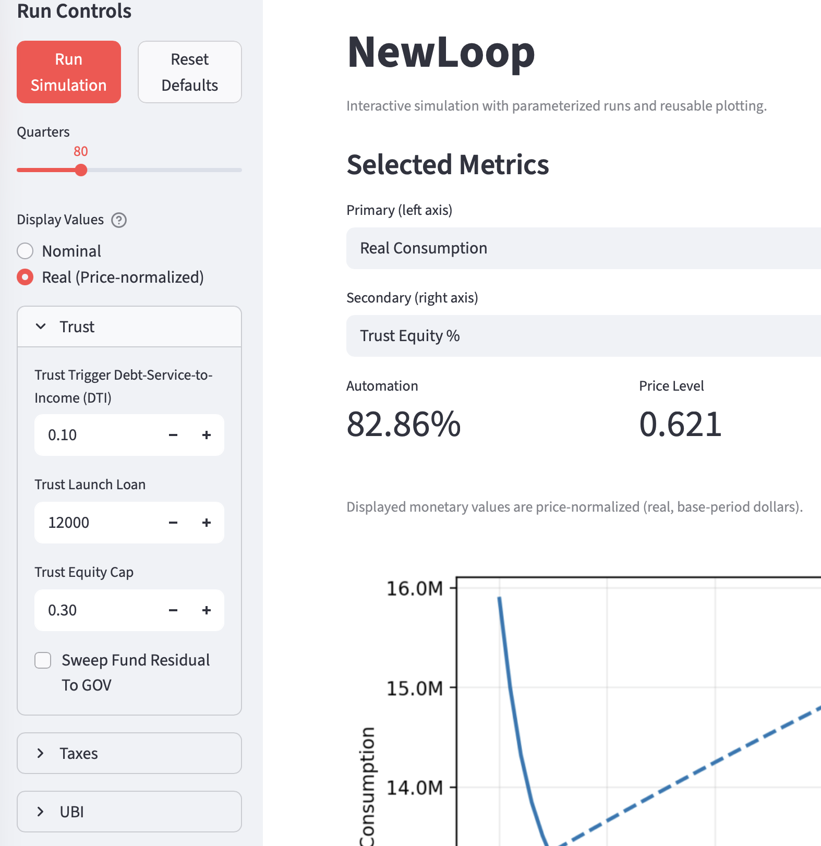
New Loop is written in Python, and its structure is therefore open to inspection by any reader who wishes to examine it directly. It is, however, a fairly detailed model, with many parameters that can be changed to observe their consequences. The purpose of this section is to illustrate what can be learned by running the model, and to emphasize that the code implements the same mechanisms described in the policy discussion above.
The partial screen capture at right illustrates that the app offers drop-down lists in a sidebar so users can change the default parameter values for a simulated run. The parameters are categorized: Trust, Taxes, UBI, Automation, Price & Capital, Population. In the Trust parameters, for instance, it might be interesting to change the size of the Launch Loan, or eliminate it altogether. In addition to many data plots, the entire quarterly stream of data generated by a simulation run is captured for inspection in a scrollable table.
New Loop is a stock-flow-consistent model. “Stocks” in this context are reservoirs of money or value connected by cash flows. Money flowing out of one reservoir must flow into another, with corresponding debits and credits, and reservoirs can become temporarily negative, representing debt or deficits.
Because the story told here is about the production-wages-consumption loop, it is essential that all cash flows into and out of the model’s nodes add up. For readers with an engineering background, this is directly analogous to Kirchhoff’s law governing electrical current flows. New Loop does not have any hidden or gratuitous cash flows to bias the results. The code is instrumented to verify that these flows remain fully consistent.
New Loop creates an initial population of 20,000 households whose incomes, invested wealth, revolving debts, and mortgages roughly parallel the proportions of those in the current United States population. Lower-income households, for example, carry more revolving debt relative to net worth. A marginal-propensity-to-consume structure is discretized over five quintiles of the population. Households are generated from a statistical distribution rather than imported from raw microdata, though that part of the code could readily be replaced with a module that reads actual household data.
Mortgages and revolving debt are the only debt instruments modeled in New Loop. Bonds are not included. That is a limitation, but probably a less serious one than it might first appear. In a real economy, bonds and equity are both reservoirs of value, though with different characteristic behaviors, and investors shift capital between them as the risk environment changes. Real estate, for example, is largely representable as either mortgage debt in the household sector or bond-financed structures in the commercial sector. Apart from the special effect of deflation on debt contracts, bonds are probably not central to the present model; and the treatment of mortgage debt demonstrates the relevant policy logic. In a persistently deflationary environment, it is likely that much commercial debt would be renegotiated rather than simply defaulted. Gold is also a surprisingly large store of value, but it is unproductive and therefore not important for the purposes of this model.
The model contains a single Bank. Corporations are represented by an Information-sector company, which adopts automation earlier, faster, and more completely, and a Physical-sector company, which adopts more slowly and ultimately less completely. These adoption paths are represented by longitudinal S-curves spanning the full eighty quarters of simulated time. Government receives taxes and issues money only as the model requires.
The model aims to be realistic where realism matters most. As automation rises, corporate productivity increases and costs decline. New Loop’s parameters govern how much of that gain is captured and reinvested or distributed to shareholders, and how much is passed through into lower prices under competitive pressure.
Mortgage payments are indexed exactly as described in the policy discussion above. The Bank receives the indexed payments, and the Government makes make-whole payments according to the terms of each household’s mortgage.
New Loop is easy to explore through the Streamlit version, which presents the model’s outputs in a web browser. A user can vary parameters and immediately see a collection of graphs showing the economic trajectory of many variables over eighty consecutive quarters. The graphs below illustrate the outputs displayed for a baseline set of parameters.

Automation curves
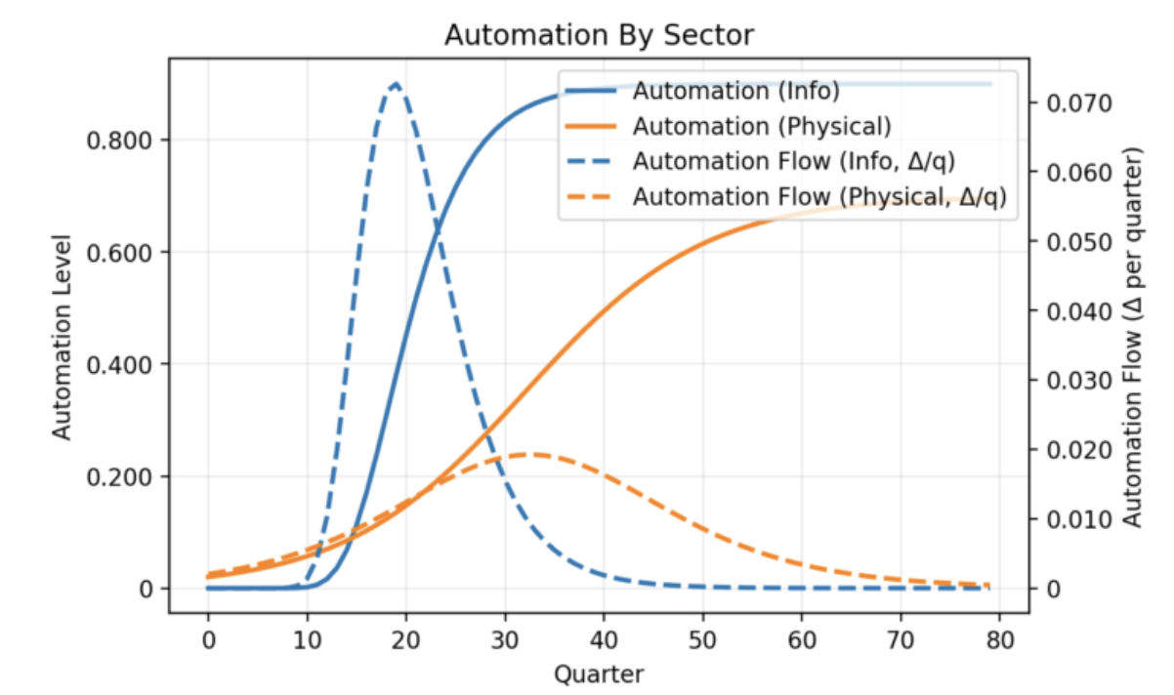
These curves depict intelligent automation adoption in the Information and Physical sectors of the economy over 80 quarters of time. The solid lines show total penetration of labor replacement. Information automation is faster and more complete, stabilizing at about 75% after ten years. Physical sector automation is slower, because it requires developing machinery, training intelligent robots, and so on. It also stabilizes below 60% total penetration after 20 years.
The dotted lines show the derivatives of the automation curves, to illustrate the different rates of change in these two sectors.

Population distributions
The next two plots show the income and wealth distributions before the new system is instituted, and at the end of the simulation. These represent real, not nominal, dollars.
The income distributions have a spike at the left, because initially there is a proportion of unemployed households with no income. The “before” state of the model does not reflect existing social security protections. The income distributions show that after 20 years, the minimum support for completely unemployed households is substantial, and the entire population has much higher incomes than before. This reflects both the UBI and the increase in corporate production with automation, since a portion of that is distributed as dividends.
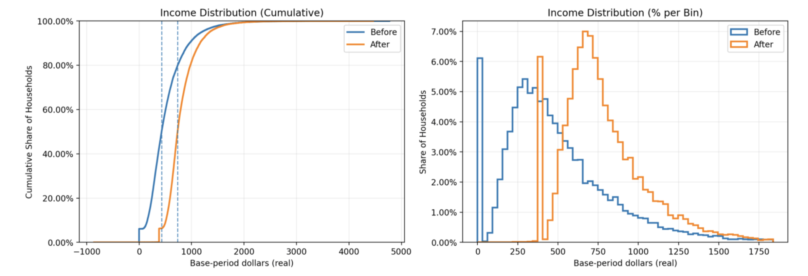
In this model run the trust equity was capped at 30%, which is reached after about 50 quarters. The wealth distributions show that at the 50th percentile (right-hand dotted line) of the right-hand chart below, households are considerably wealthier, in real terms, than they were before. Among the wealthiest household, total wealth is somewhat reduced but not dramatically. This represents two effects: equity dilution, which is a slow and capped wealth tax, but also gain in total wealth over time due to continuing productivity improvements and greater total output.
Although not illustrated here, there is nothing magic about the 30% equity cap. The numbers work out acceptably well at 25%, or at 35%. The policies working together have a broad range of stability.

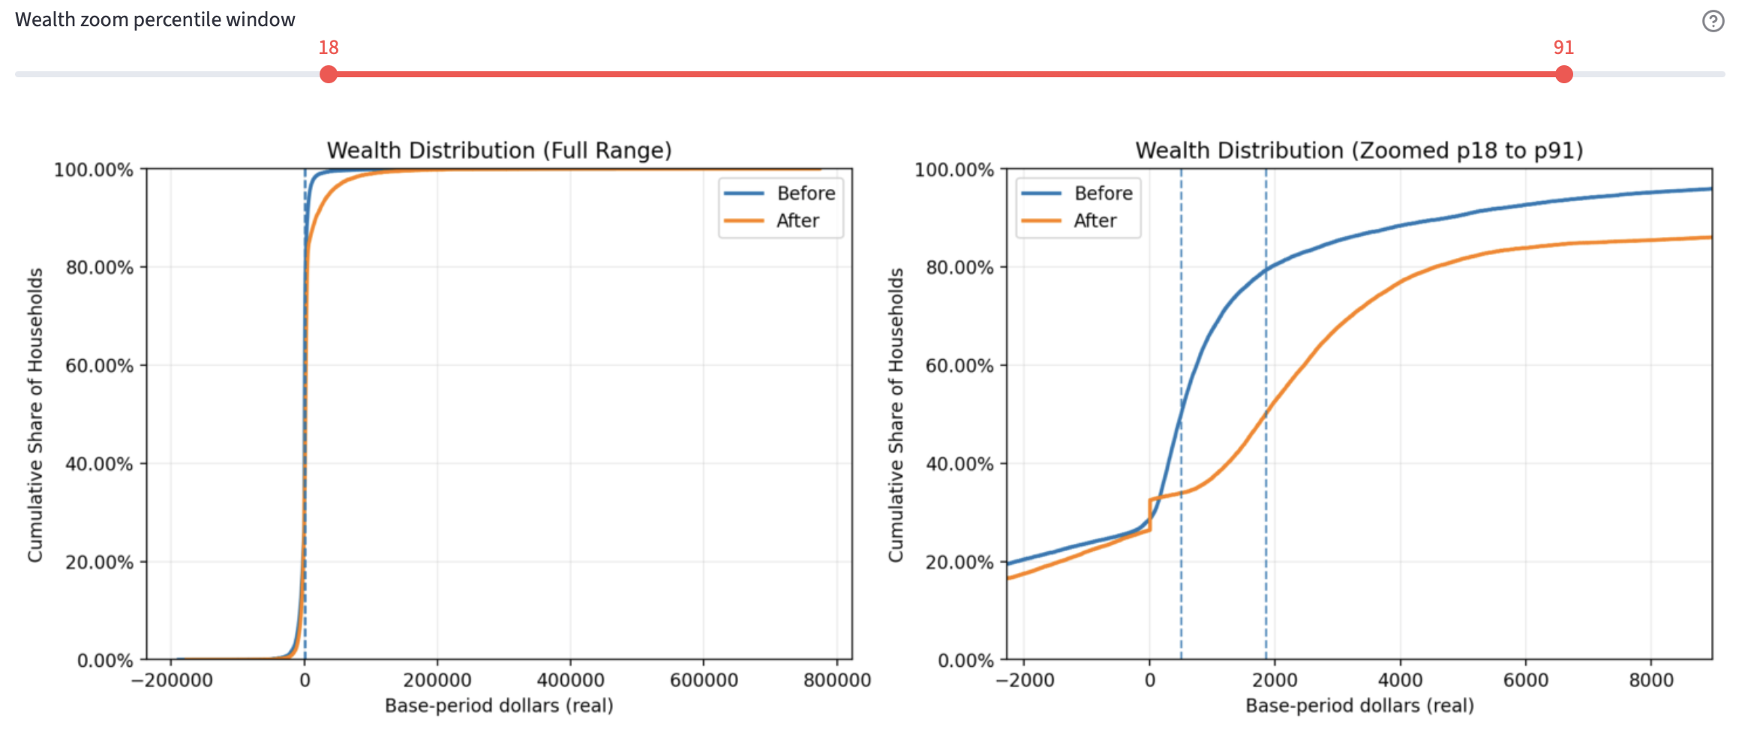

Inequality (Gini metrics)
The wealth distribution might be easier to understand as Gini metrics. New Loop plots three measures of inequality throughout the simulation run. In the plot below, the green line shows wealth inequality among the 20,000 households. The blue line shows household inequality of income before income tax, VAT credit, UBI, and debt service. It is essentially unchanged in real terms over 80 quarters. The orange line shows disposable income inequality after all tax and support transfers.
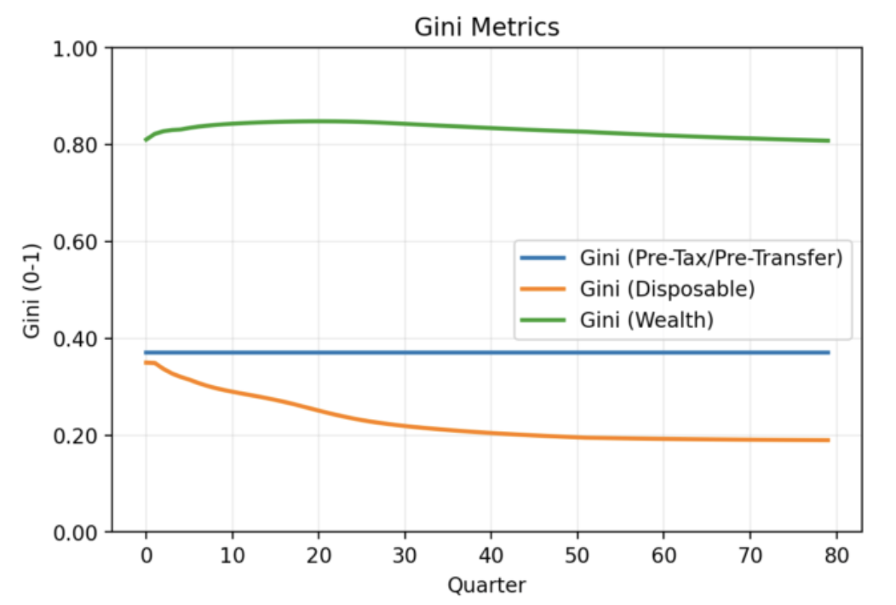
This plot reveals two things. First, the transition policies altogether improve inequality of disposable income. The whole population can actively consume and support the new macroeconomic production - consumption loop.
Second, the green wealth line shows that households that were wealthy before the automation transition remain so after it. There has been some shift, as the zoomed Wealth Distribution plot show, above. But the hierarchy of wealth in the population has not changed very much. The wealthy have not really been hurt.
This is important: it shows that the proposed policies demonstrably do not play out as a socialist or confiscatory regime. The New Loop is still a capitalist society. Entrepreneurs and investors can still reap big rewards. In fact, the UBI and other policies make it safer to take financial risks and create innovations.

UBI and real household outcomes
The UBI funding mix ought to show substantial contributions from tax take, trust fund distributions, and government issuance, and it does. The left-hand plot shows per-household UBI distributions growing steadily for about 30 quarters, then beginning to slowly level off. UBI from the trust fund grows until Q50, when the equity cap is reached. Tax contribution widens continuously, reflecting both increased output from reinvestment, and VAT.
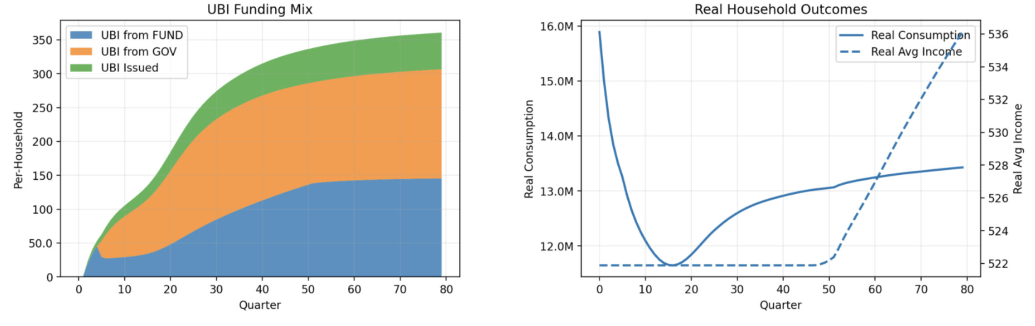
The left-hand plot also shows UBI Issued as a small but slowly growing amount of real dollars. This reflects two intentional policy choice in the model. UBI is not allowed to decrease, only increase, even if the government must issue money to fulfill the commitment. A little money issuance is inflation-safe and lubricates the system, because the economy is in a persistent deflationary state.
This can be seen in real average income (dotted line, right-hand plot), and real consumption. The flat regime is the clamped UBI (never allowed to decrease). After 50 quarters it rises steadily and at a pretty good clip. Real consumption falls at first, as the policies take time to work. But then it rises. This is governed mainly by parameters that control how much of reduced cost and increased output are allowed to flow into price reductions, versus being captured as more corporate profit and either reinvested or distributed as dividends.

The model reveals serious stresses during the transition
Despite the policy backstops, this transition will not be painless. An advantage of modeling is that we can know what’s coming, and plan for it or perhaps adapt the policies a bit. For instance:
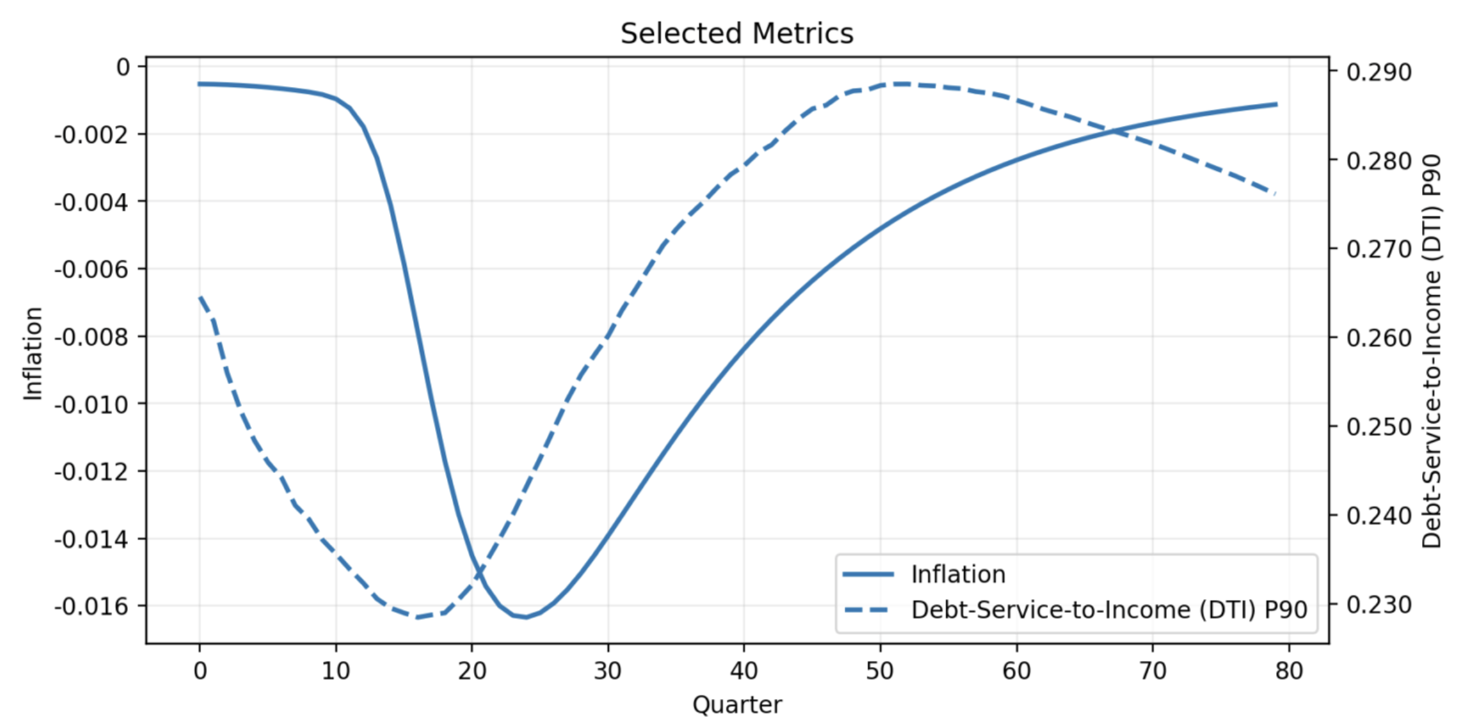
The solid line traces the deflation process, with (negative) inflation on the right-hand Y-axis. Prices fall steeply as the automation adoption process plays out, but after Q25 things turn around. After 20 years, deflation has pretty much ended.
Under the policies, while UBI is never allowed to decline, indexed mortgage payments shrink with deflation, and government makes up the difference to the bank. The consequences for households appear in the Debt-Service-to-Income (DTI) dotted line, which is plotted to include households up to the 90th percentile (P90). Because mortgage payments are indexed to deflation, debt service rises as a fraction of income when deflation starts working itself out of the system and consumption grows. After 20 years, deflation is over, real incomes are rising, and DTI begins to fall. It would continue falling if we ran the simulation for more than 80 quarters.

The parameters associated with the policies introduced in this paper are explained in a separate document.

